Sri Lanka Institute of Information Technology

# Comprehensive Design Analysis Project

# **AI Solution to assist online education productivity via personalizing learning strategies and analyzing the student performance**

# Project Id: 2022-017

Logbook

IT19120362

Thammita D.H.M.M.P.

13th of November 2022

Table of Content

1. Our journey 3
2. Screenshots of MS team and Chats 5
3. WhatsApp Chat Group for Continuous Communication with Team Members with Supervisor/Co-Supervisor/External Supervisor …………………………………………………………………………………………………15

# Our Journey

We are Here Now

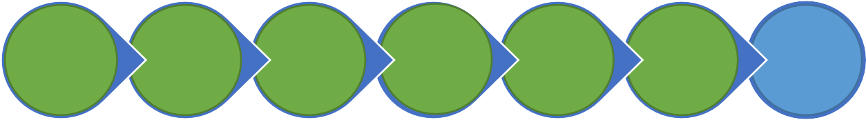

**Project pre-**

**assessments (Topic Evaluation)**

**Project**

**Proposal Presentation**

**Progress**

**Presentation - 1**

**Progress**

**Presentation - 2**

**Demo &**

**Poster**

**Final**

**Presentation & Viva**

**Feasibility Study and Supervisor Selection**

|  |  |  |
| --- | --- | --- |
| **Event** | **Date/Time** | **Summery** |
| Feasibility Study & Supervisor Selection | December 2021 – January 2022 | * Formed a research group with 4 members. * Gathered ideas of team members about the research topics. * Evaluated each research topic proposed and selected best four research ideas. * Documented selected research ideas and presented to the tentative supervisors. * Selected Prof. Samantha thelijjagoda as our supervisor and Co-supervisor as Ms. Archchana kugathhasan. Mr. Koliya harshanath joined as the external supervisor. * We selected our research topic as Machine learning based personalized education platform. Then we registered our research topic. |
| January 2022 | * Conducted a feasibility study the determine the feasibility of the selected project. * Completed feasibility study document. * Presented the feasibility study to the supervisors. |
| Project pre-assessments (Topic Evaluation)  &  Project proposal presentation | January 2022 | * Started the literature Survey and documented it. * Presented the literature Survey to the co-supervisor and got comments. * Modified the literature survey according to the suggestions of supervisor. * We referred existing research papers on the chosen domain and identified the research gap with current systems that are in the market. * Created a project proposal document with guidance of supervisor, external supervisor and co- supervisor. * The presented the proposal to the panel, and it got accepted. |

|  |  |  |
| --- | --- | --- |
|  | January 10 , 2022 | * Started Discussions on Model implementation with co-supervisor. * Initial system model designed. * Analyzed the system components. * Completed System architecture design |
| January 24, 2022 | * Initial model implementation started. * Technologies and potential machine learning models evaluated. |
| February 2022 | * Data gathering phase started. * Designed initial data gathering survey and distributed. * Learning scope identification component implementation started. * Presented progress to the co-supervisor in by weekly meetings * Best models were chosen to develop the learning material recommendation component. |
| Progress Presentation – 1 | April 8 – 6.00am  – 7.30am | * Had a meeting with the external supervisor to discuss the progress of the implementations. |
| May 12 | * Model implementations completed. * Frontend initialized with basic functionalities and integrated with backend |
| 14th May 2022 | * By the time of progress presentation 1, completed entire learning scope identification model and more than 50% of the learning material recommendations model. |
| Implementation Phase 2 | June 2022 | * Implemented learning material extraction functionalities. * Continued development of learning material recommendation module. |
| July 2022 | * Had initial discussion about research paper writing with co-supervisor. * Research paper writing started. * Learned Latex to write the research paper. * Completed introduction parts of individual research papers and presented to the co-supervisor for comments. * Continued system development and presented the progress to the supervisor bi-weekly. |
| August 2022 | * Modified research paper according to the supervisor’s suggestions. * Completed remaining parts of Research paper. * Re submitted draft research paper for supervisor comments. * Modified the paper according to the comments and re submitted. * Continued system development and presented the progress to the supervisor bi-weekly. |
|  | September 2022 | * Research paper submitted to the UEMCON. * Completed UI aspects of the application. * Completed learning material recommendation component and integrated with the learning material recommendation module. |
| Progress Presentation - 2 | 11th and 13th of October | * Integrated the separate components of the system. * By the time of progress presentation 2, implementations are completed by 90%. Research paper is accepted by UEMCON * Created a poster for the presentation. |

|  |  |  |
| --- | --- | --- |
|  | November 6 - 12 | * Had some meetings to finalize the system. Did some unit testing and integration testing. Did some improvements to increase the accuracy of * the model. * Fixed identified bugs. * Application Deployed to the cloud. |

* 1. Screenshots of MS team and Chats

## Teams group for research team – continuous communication

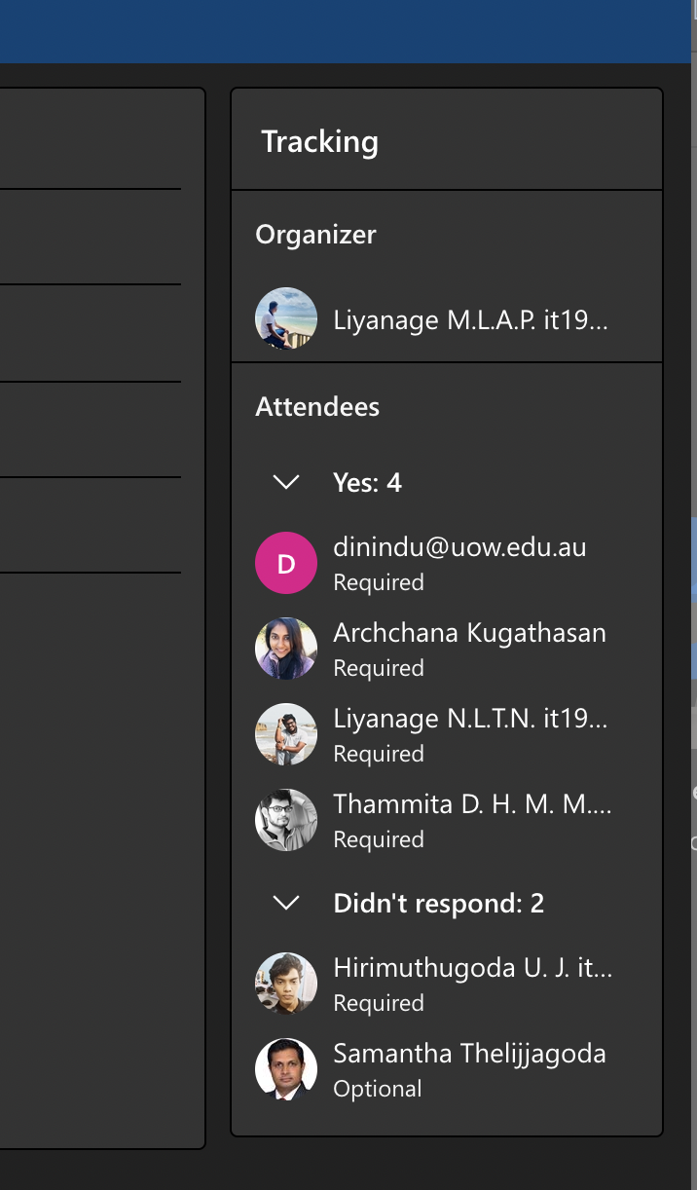

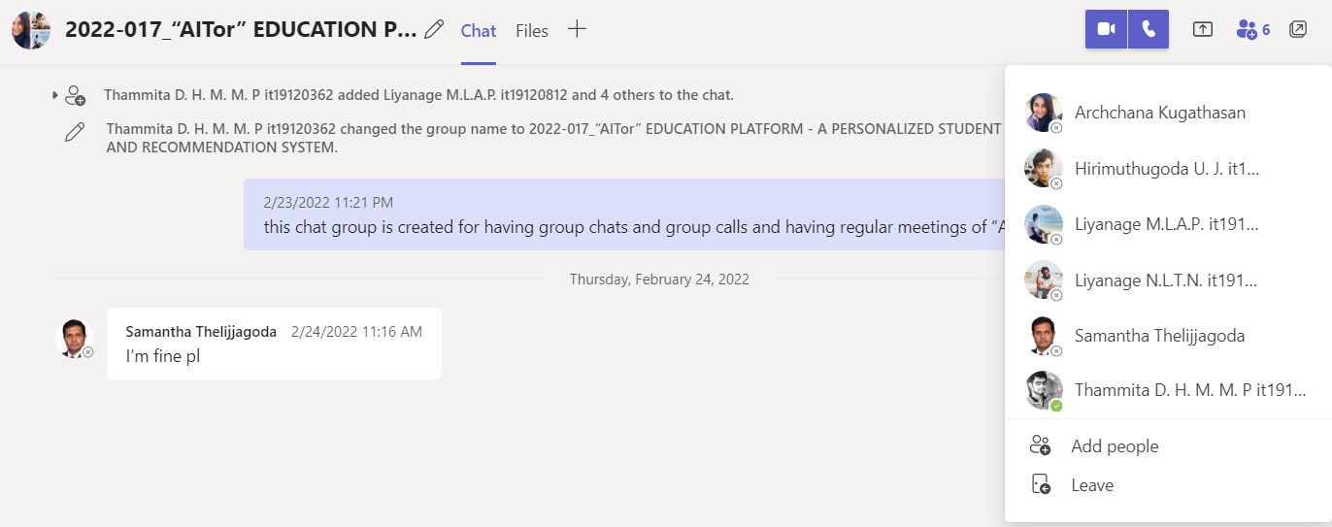

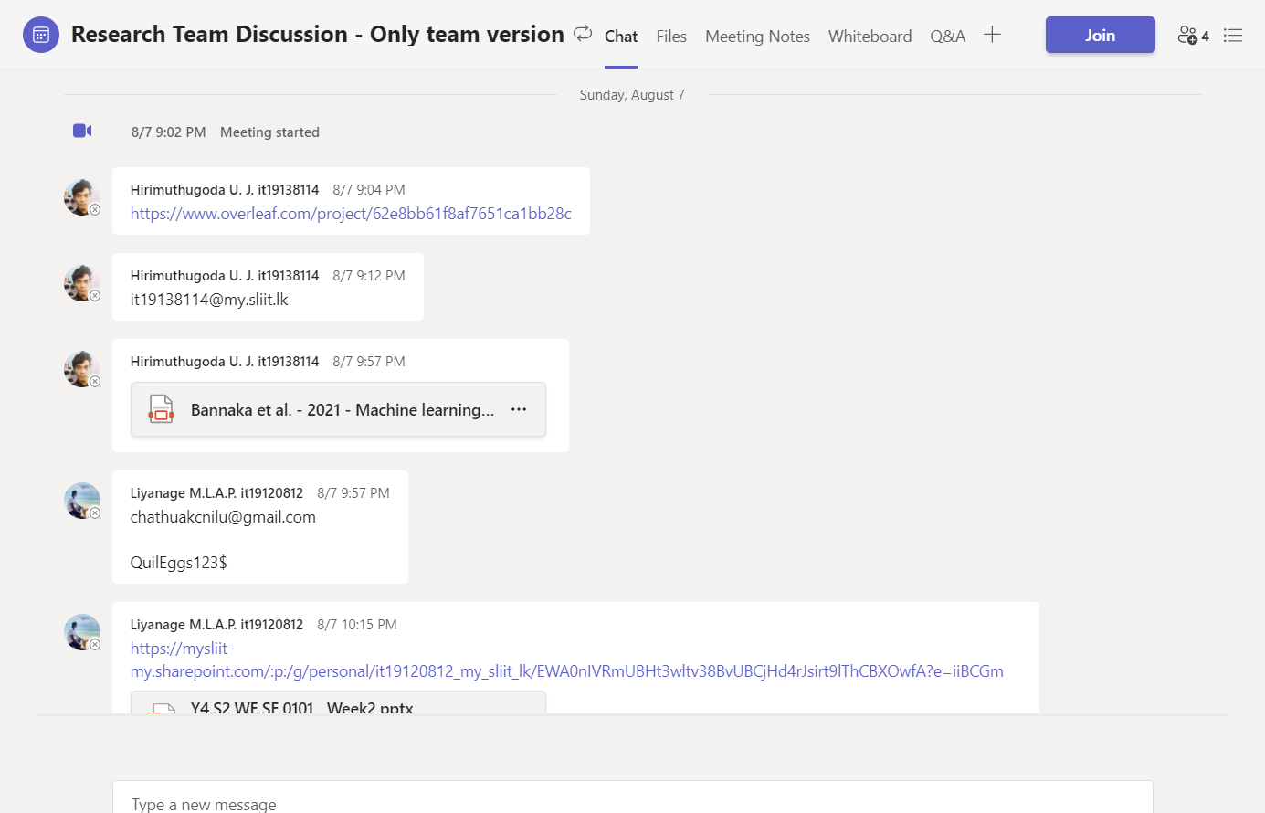

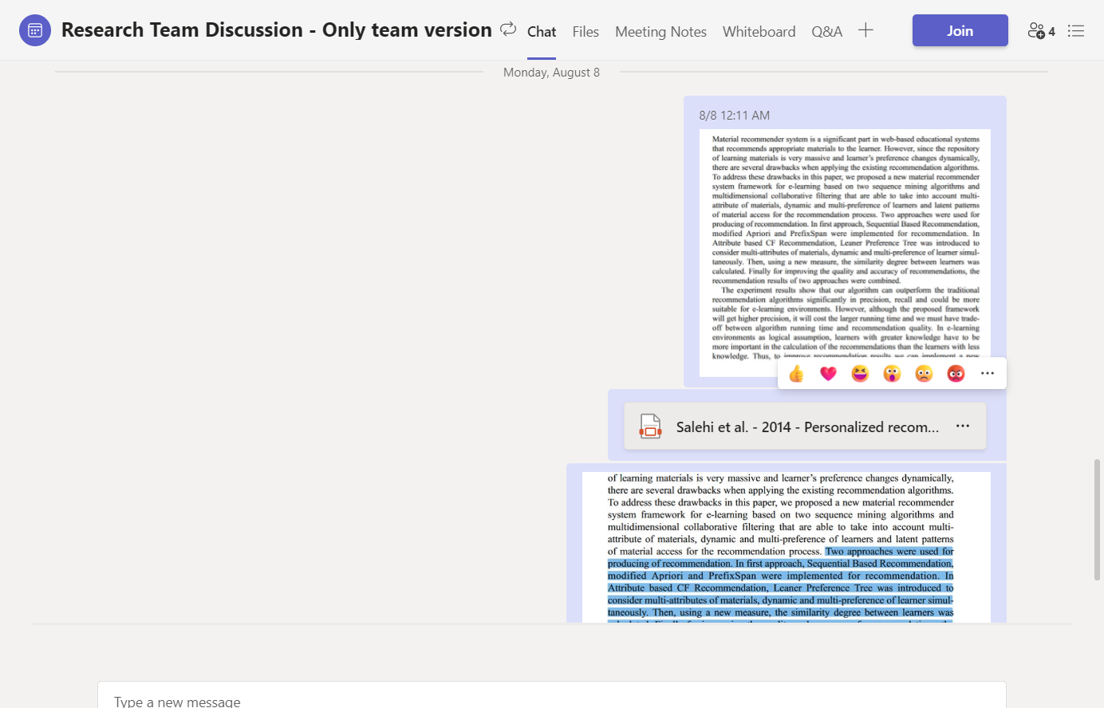

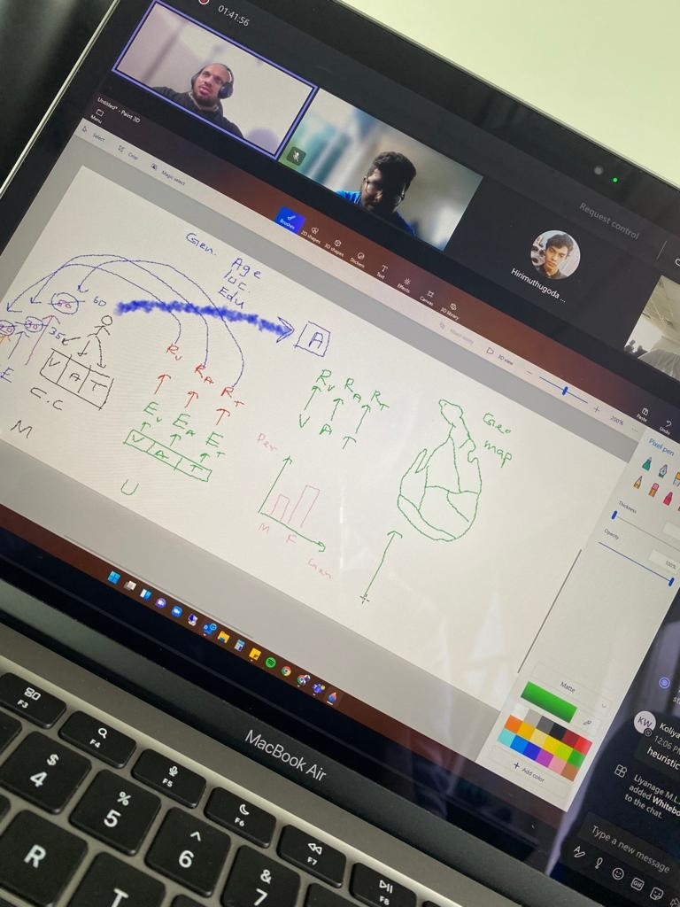

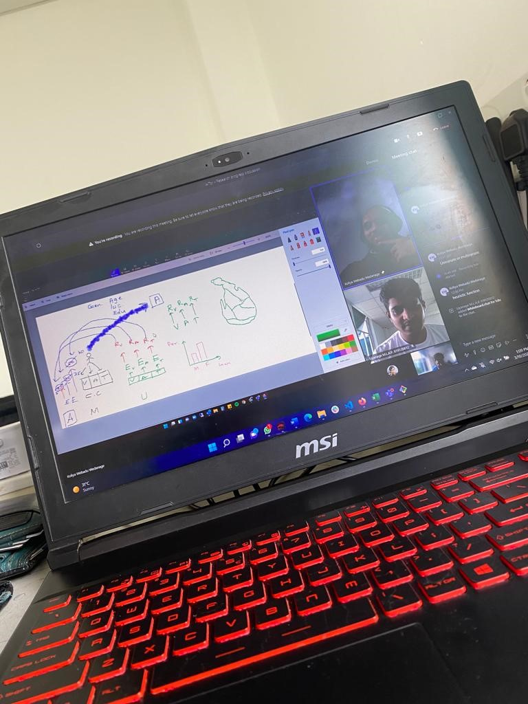

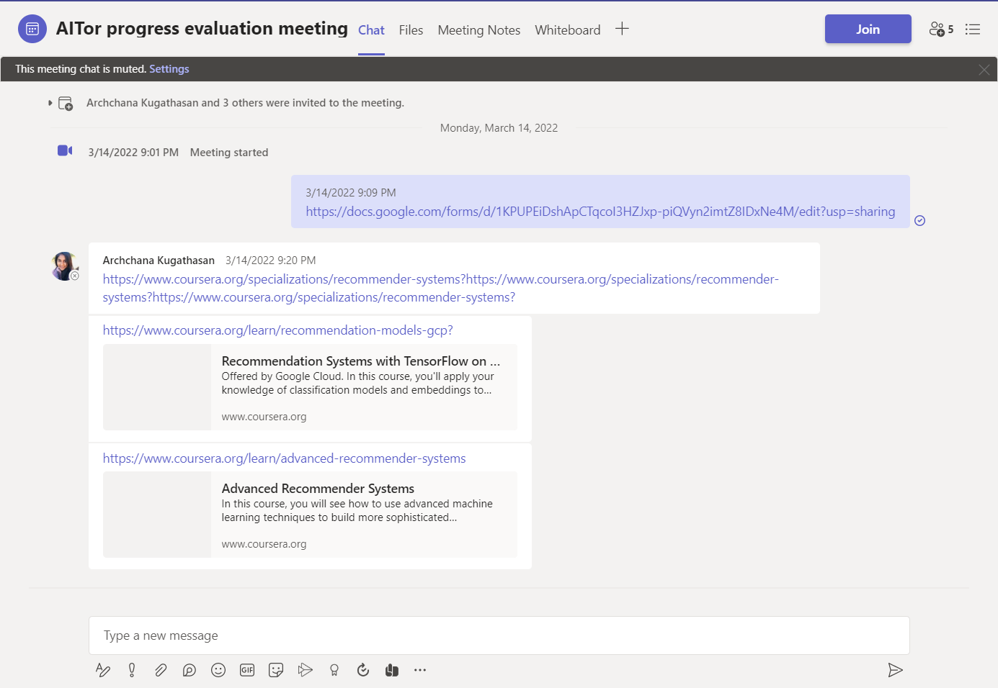

## Research team members only MS team

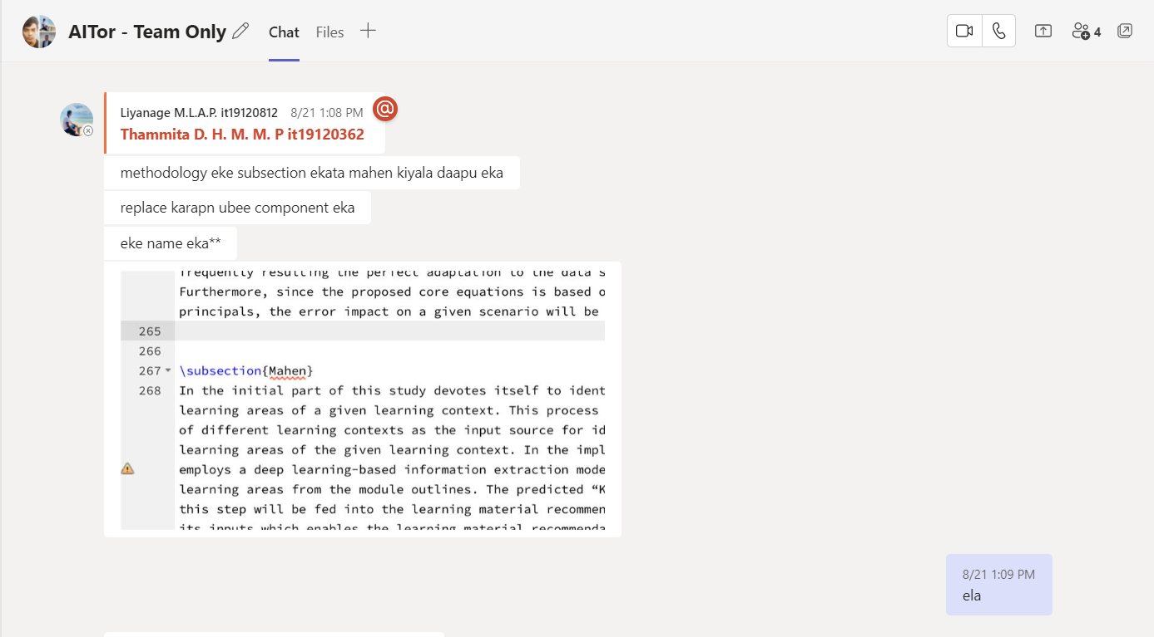

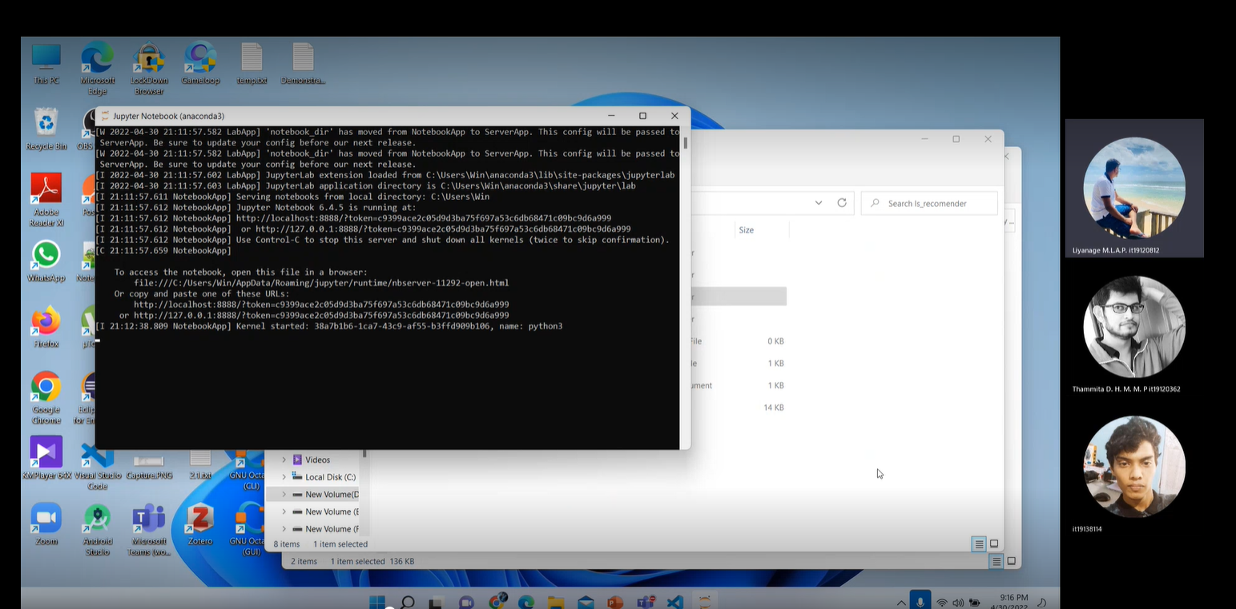

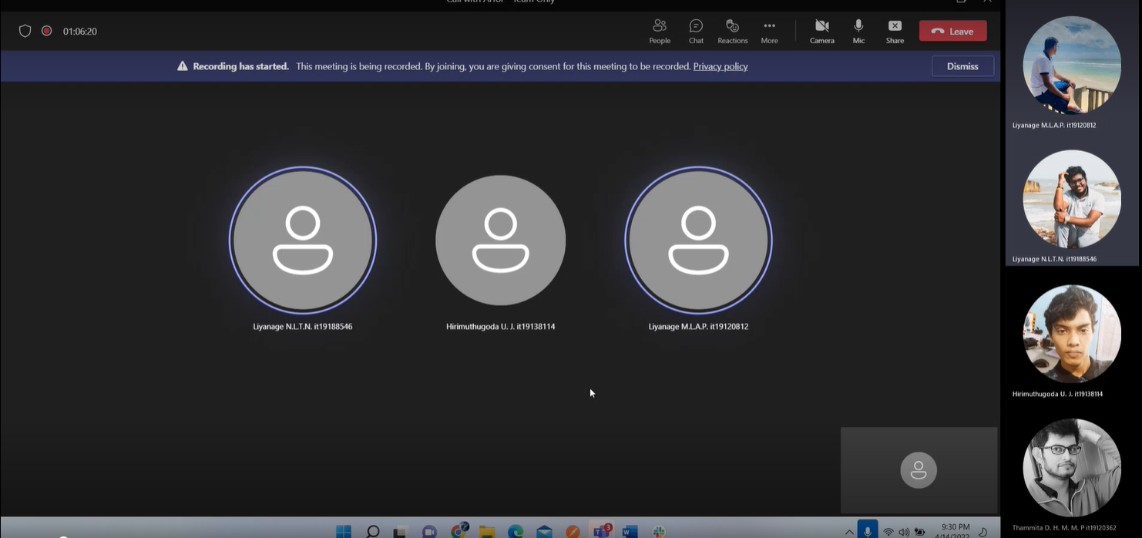

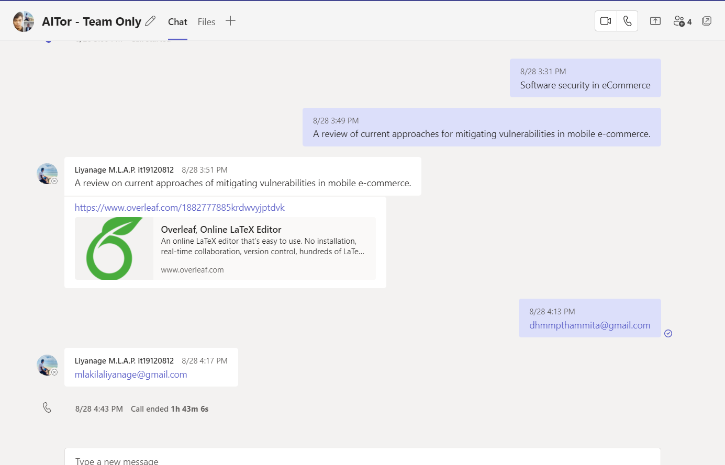

# WhatsApp Chat Group for Continuous Communication with Team Members with Supervisor/Co-Supervisor/External Supervisor.

